

**Byte Synergy 2.0**

**Project Title:** Online Blockchain-Based Certificate Generation and Validation System for Government Organizations

**Team Information:**

* **Team Name:** DigiChain Masters
* **Team Members:**

Shashi Ranjan

Suraj S

Manoj Kumar S

* **College Name:**

Reva University, Kattigenahalli, Yelahanka Bangalore -560064

**Abstract:**

We generate and verify a wide variety of documents and certificates since they serve as documentation. The generation of phoney certificates is becoming simpler. Therefore, validating and verifying these credentials and making them tamper-proof are given top attention. Our project seeks to address this issue by implementing a secure blockchain-based system for certificate storage and verification. The digital certificates are securely stored within the blockchain network. Verification and validation of these certificates are facilitated through a dedicated mobile and web application. Leveraging blockchain technology, we aim to establish a highly secure and efficient framework for digital certificate validation, providing enhanced security and trustworthiness in the process.

**Introduction:**

Our process begins by transforming conventional paper certificates into modern digital formats, or generating digital certificate. We then harness the power of a robust cryptographic algorithm to craft unique hash codes for each certificate, ensuring their integrity and security. These transformed certificates find a safe haven within the secure confines of a blockchain network.

But we don't stop there. Our commitment to trust and security continues with the development of a dedicated mobile and web application, specifically designed for the swift and reliable verification and validation of these digital certificates.

By harnessing the transformative potential of blockchain technology, we aspire to redefine the landscape of digital certificate validation. Our goal is clear: to establish an exceptionally secure and efficient framework that reinvigorates trust and security in the verification process. Join us on this journey towards a future where digital certificates are not only reliable but also a symbol of absolute confidence.

**Problem Statement:**

Government organizations face a myriad of challenges in managing and issuing certificates, such as diplomas, licenses, and permits. Some of these challenges include:

1. *Certificate Fraud:* Instances of counterfeit certificates and document forgery erode trust in the validity of issued credentials.
2. *Document Tampering:* Vulnerabilities in traditional certificate storage make it possible for malicious actors to alter certificates.
3. Inefficiency: The manual issuance and verification of certificates consume valuable time and resources.

**Architecture:**

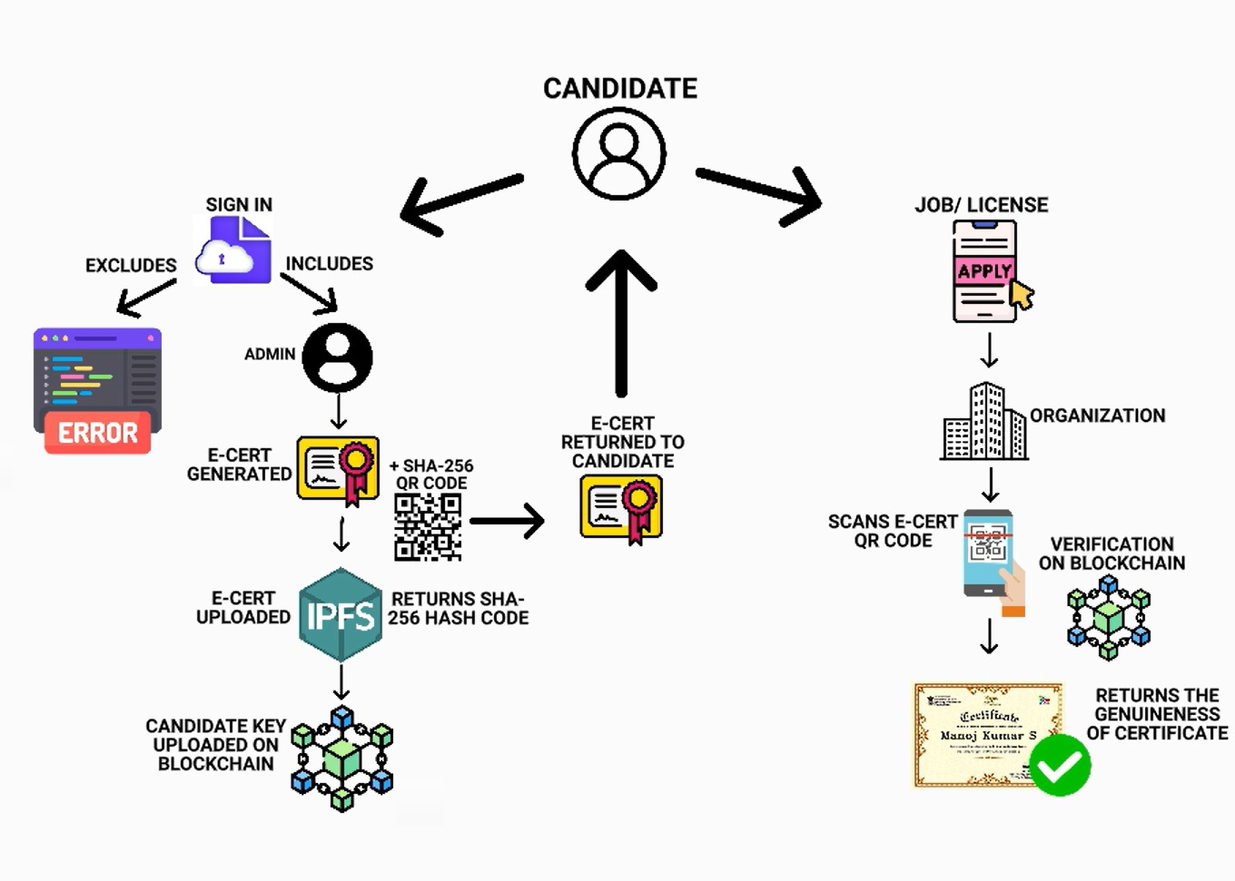

**From a Student's Perspective:**

1. **DigiLocker Integration:**

"We've simplified your authentication process! With DigiLocker integration, you can securely log in, ensuring your personal information is always protected.”

1. **Certificate Generation Process:**

"Your certificates are now fortified with the robust SHA-256 algorithm, guaranteeing their authenticity. No more worries about tampering – your achievements are secure and recognized."

1. **QR Code Integration:**

"Your certificates now come with a unique digital key – a QR code linked to a secure hash. It's your passport to verified accomplishments, ready to be scanned whenever you need it."

1. **E-Certificate Distribution:**

"Say goodbye to paperwork! Your electronic certificates (e-certs) are digitally delivered, making record-keeping a breeze. Access your achievements anytime, anywhere, hassle-free."

**From an Institute's Perspective:**

1. **DigiLocker Integration:**

"Simplify administrative tasks with our seamless DigiLocker integration. It ensures a smooth login experience for students and staff, enhancing the efficiency of your institution."

1. **Certificate Generation Process:**

"Ensure the integrity of your institution's certificates. Our SHA-256 algorithm guarantees each certificate's uniqueness, building trust among stakeholders and maintaining the institution's reputation."

1. **QR Code Integration:**

"Empower your certificates with digital keys! QR codes, securely linked to unique hash codes, provide instant verification. Uphold the credibility of your institution's achievements effortlessly."

1. **E-Certificate Distribution:**

"Optimize your certificate distribution process. Electronic certificates are delivered instantly, reducing manual efforts and enabling timely recognition of your students' accomplishments."

1. **IPFS for Resilient Storage:**

"Rest easy with our decentralized IPFS storage. Each certificate receives a unique IPFS address, enhancing accessibility and ensuring data resilience. Your institution's records are securely stored and easily retrievable whenever needed, providing a reliable foundation for your academic legacy."

**From a Company's Perspective:**

1. **DigiLocker Integration:**

"Simplify your recruitment process! Our DigiLocker integration ensures the authenticity of candidates' certificates, allowing you to make informed hiring decisions swiftly and securely."

1. **Certificate Generation Process:**

"Trust in the authenticity of candidates' qualifications. Our SHA-256 algorithm guarantees tamper-proof certificates, providing you with reliable insights into applicants' skills and expertise."

1. **QR Code Integration:**

"Efficiently verify candidates' credentials with QR codes. Instantly authenticate certificates by scanning the QR code, ensuring the qualifications match your hiring criteria accurately."

1. **E-Certificate Distribution:**

"Streamline your onboarding process. Electronic certificates facilitate seamless document verification, enabling a swift transition from candidate selection to a productive workforce."

**Implementation:**

1. **Certificate Generation:**

Certificates are generated based on data retrieved from a CSV file stored in the database. This data includes information like student names, course completion dates, and other relevant details. Thecertificate generation process involves creating certificate templates and overlaying student-specific information onto these templates. OpenCV is used for image manipulation to generate the certificates.

Certain conditions are checked before generating certificates. These conditions might include verifying the student's eligibility for a certificate, checking if the course was completed successfully, etc. The certificates are attached with a unique qr code generated using users credentials by SHA-256 algorithm. This qr-code acts as a *KEY*. Once certificates are generated, they can be securely stored on the blockchain for verification purposes. This step involve integrating with a specific blockchain platform.

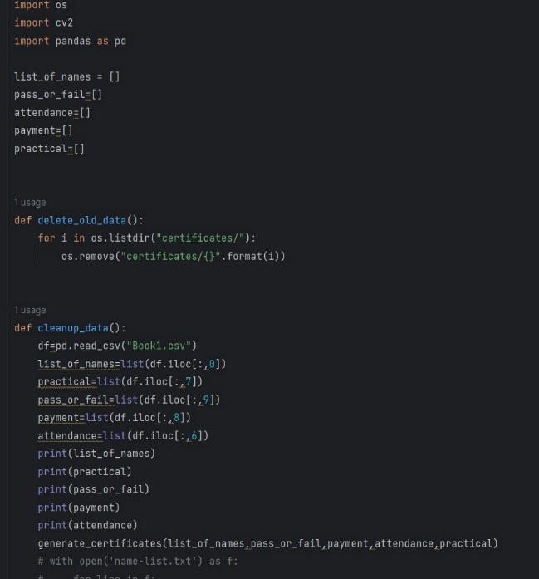

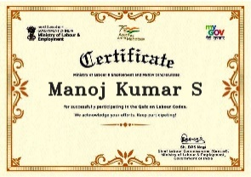 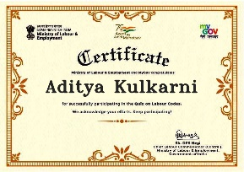

1. **Certificate Validation:**

This report provides an overview of the certificate validation process implemented in our project, which utilizes IPFS (Interplanetary File System) for secure certificate storage and QR code generation for user-friendly verification. Upon certificate generation, the certificate is securely uploaded to IPFS, a decentralized and immutable file storage system. This step ensures that the certificate remains tamper-proof and accessible for verification purposes. A SHA-256 hash is computed for the certificate stored on IPFS. This hash serves as a unique identifier for the certificate, ensuring its integrity. This identifier acts a *VALUE* to the corresponding *KEY* attached to the certificate.

This *KEY-VALUE* pair is then uploaded to blockchain. Once a block is added to the blockchain and several subsequent blocks are added on top (forming a chain), it becomes extremely difficult to alter the information in the block. This immutability is due to the cryptographic hash functions and the consensus mechanisms used in blockchain technology.

IPFS integration is a critical component of our certificate validation process. IPFS offers the following advantages: Decentralization, Immutable Records, Global Accessibility. QR code generation from the SHA-256 hash offers several benefits: User-Friendly, Quick Verification, Reduced Error.

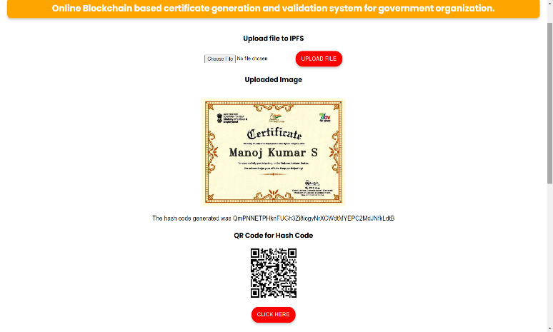

1. **Certificate Verification**

This report provides an overview of the certificate validation process implemented in our project, which utilizes IPFS (InterPlanetary File System) for secure certificate storage and QR code generation for user-friendly verification. Upon certificate generation, the certificate is securely uploaded to IPFS, a decentralized and immutable file storage system. This step ensures that the certificate remains tamper-proof and accessible for verification purposes.

A SHA-256 hash is computed for the certificate stored on IPFS. This hash serves as a unique identifier for the certificate, ensuring its integrity. Whenever a certificate is presented in front of someone, they can verify whether it is legit or not in just 2 steps:

1. Scan the qr code(*KEY*) present on the blockchain.

2. If the corresponding *VALUE* to the *KEY* is present on the blockchin, that means the certificate is legit.

IPFS integration is a critical component of our certificate validation process. IPFS offers the following advantages: Decentralization, Immutable Records, Global Accessibility. QR code generation from the SHA-256 hash offers several benefits: User-Friendly, Quick Verification, Reduced Error.

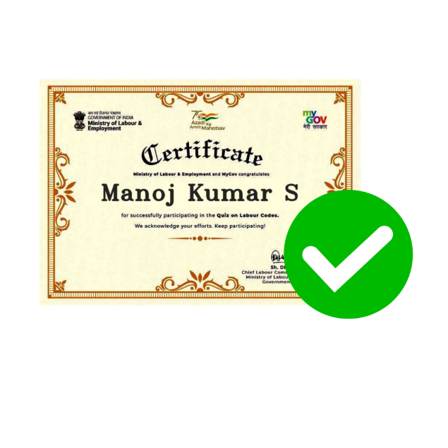

**Technology Stack:**

Our project leverages the following technologies:

1. *Blockchain*: Ethereum for secure and transparent ledger functionality. IPFS for decentralized file storage.
2. *Smart Contracts:* Developed in Solidity to create immutable records.
3. *Frontend*: HTML, CSS, and JavaScript for a user-friendly web interface.
4. *Backend:* Node.js for efficient data management.
5. *Programming languages:* python (OpenCV), JavaScript, solidity.

**Future Enhancements**:

To further enhance our system's capabilities, we plan to implement the following improvements:

1. *Interoperability:* Integration with other blockchain networks to broaden compatibility and increase accessibility.
2. *Mobile Application:* Developing a mobile app for quick and convenient certificate validation.
3. *Advanced Security:* Implementing multi-factor authentication to enhance security measures

**Impact and Benefits:**

Our system is poised to deliver significant benefits, including:

1. *Enhanced Security:* By utilizing cryptographic algorithms and storing certificates on a blockchain network, the security and integrity of digital certificates are greatly improved. This can help prevent fraud, counterfeiting, and unauthorized alterations.
2. *Ease of Verification:* The dedicated mobile and web application simplifies the process of verifying and validating digital certificates. This can lead to quicker and more reliable verification, reducing administrative burdens for organizations and individuals.
3. *Blockchain Adoption:* Implementing blockchain technology for certificate storage and verification can promote wider adoption of blockchain in various sectors beyond cryptocurrency. It showcases the versatility and benefits of blockchain in ensuring data integrity.
4. *Competitive Advantage:* Organizations offering such services may gain a competitive edge by providing a secure and convenient solution for certificate management and verification.

**Real Life Applications**

1. Validate government-issued identification documents such as passports, national IDs, Income certificate , Caste certificate and driver's licenses can be validated by using Our software which is capable of Checking whether the Certificate is Real or fake.
2. Schools and Universities can validate the academic degree of the candidate issued by the educational institutions by using our software.
3. Ensure that healthcare professionals, such as doctors, nurses, and pharmacists, hold valid licenses and credentials. This can be validated by medical board officers where our software can be implemented.
4. As we know that the future recruitments are going to happen through online where the candidates can upload their Certificates in the mentioned website. Government agencies or private agencies can implement our software to validate the certificates uploaded by the candidates.
5. Verify certifications related to food safety and quality standards for restaurants, food producers, and distributors.

**Conclusion:**

In conclusion, the implementation of blockchain and IPFS technology for the generation and validation of digital certificates for government organizations represents a significant leap forward in ensuring the authenticity and security of critical documents. This project addresses the pressing need for a tamper-proof and easily accessible system to verify candidates' certificates, which is paramount for government institutions. By leveraging these cutting-edge technologies, we establish a transparent, immutable, and efficient platform that enhances trust, minimizes fraud, and simplifies the verification process. As a result, this project not only streamlines administrative procedures but also upholds the integrity and credibility of government-issued certificates, fostering a more reliable and accountable credentialing system for the benefit of both organizations and individuals.